GOLDEN TEMPLE TOUR

Day 01 Arrival Delhi

Arrive Delhi. You will be met by our representative at the airport & escorted till your check in at Hotel.

Delhi, the Empress of Indian cities has a fascinating history and a stimulating present. She has often been sacked and left naked and desolate. But she could not be despoiled of the incomparable situation that marks her for the metropolis of a Great Empire. The capital of India, Delhi has been the seat of power of a number of dynasties – the Rajputs, the Afghans, the Turks and the Mughals who continued their imperial line until the British. Scattered over are surviving ruins, remnants of mighty edifices, tombs of warriors and saints, which in an impressive sense of magnificence are memorials not of a single city but of supplanted nations.

Overnight at Hotel.

Day 02 Delhi – Amritsar

Morning combined city tour of Delhi visit the Qutub Minar and Humayun’s Tomb and drive past India gate , Red Fort & President’s house.

The city’s earliest surviving Islamic monuments, the Qutab mosque and minar created by the founder of the sometimes, called the Slave Dynasty, Qutb-ud-din- Aybak. 73 meters high and consisting of 5 storeys, the Qutab Minar construction started in 1199 on what was intended to be the most glorious tower of victory in the world.

The Humayun’s Tomb was built in the 16th century by the second Mughal emperor. This is an early example of Mughal architecture.

Afternoon transfer to railway station to board train to Amritsar, leaving Delhi at 1630 Hrs & arriving Amritsar at 2230 hrs .

Your will be met by our representative at railway station & transfer to Hotel.

Situated on the northwestern border of the country, Amritsar means the “Pool of Nectar”, the name derived from a pool constructed at a sacred site gifted by Akbar to Guru Ramdas in the 6th century. This 400-year-old city has been the center of Sikh religion and culture since the time of its inception and is famous for the Golden Temple.

Life in Amritsar is deeply influenced by the holy shrines of the Golden Temple and the Durgiana Temple, plus the sources of the city’s wealth-agriculture, commerce and industry. Even though most people are very religious, they are also extremely fun loving and full of life. They have earned their money by sheer hard work, and they spend it lavishly on the good things of life.

Overnight at hotel.

Day 03 In Amritsar

Morning after breakfast proceed for city tour of Amritsar.
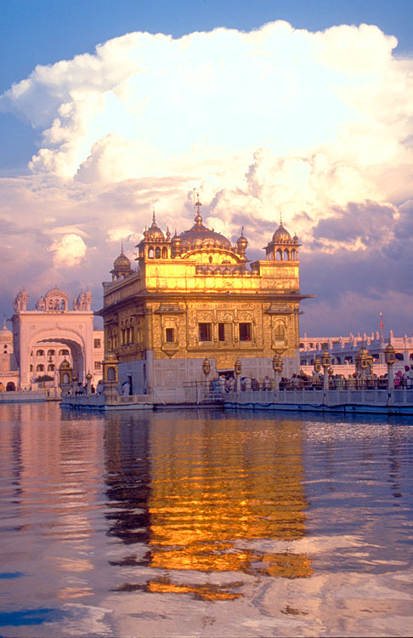
Golden Temple Located in the heart of the city is the Golden Temple, the most visited tourist attraction of Amritsar. Characterised by its four entrance doors (called deoris) in all four directions and the tastefully decorated shrines, in terms of art and architecture, the Golden Temple welcomes everyone regardless of the religion or faith one follows. The stunning sanctum, shimmering in the water of the holy tank, flanked by spotlessly clean marble walkways and pavements makes it breathtakingly beautiful.

Jalianwala Bagh : A historical monument that tells the sad story of mass killing during the independence movement in India, Jalianwallah Bagh is another must visit in Amritsar. Here lies the memorial of the martyrs of the 1919 massacre by British General Dyer. Presently the place also has a park. The Martyr's Gallery is open from 9 am to 5 pm in summers and from 10 am to 4 pm during winters.

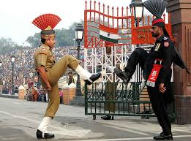
Wagah Border : One of the many nearby places to visit from Amritsar is the Wagah Border. Located on the Indo-Pakistan border, Wagah is 28 kilometres from the Amritsar main town. A good number of visitors come to this place to see the change of guards ceremony and the flag hoisting and lowering activities which are done with great skill and precision by the border security forces of both the countries. A site you cannot afford to miss.

Overnight at Hotel.

Day 04 Amritsar-Delhi (By Train)

Morning Free.

Afternoon transfer to railway station to board train to Delhi, leaving Amritsar at 1655 Hrs & arriving Delhi at 2305 Hrs. On arrival in Delhi in time transfer to airport to connect flight for onward destination.

***************************************************************************************

